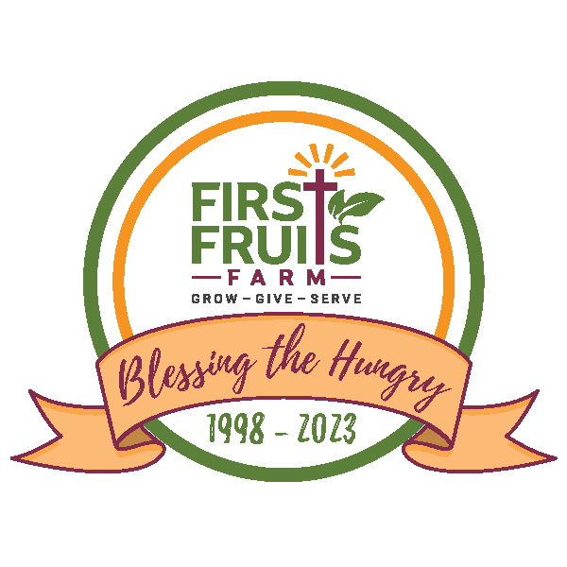
FOR IMMEDIATE RELEASE Contact: Natalie Van Buskirk/Nicole Halsey
May 19, 2023 Polished Nichols Public Relations & Marketing
443-956-4765/410-952-2122
Natalie_vanbuskirk@yahoo.com
Nicolehalsey05@gmail.com

FIRST FRUITS FARM CELEBRATES DISTRIBUTION CENTER OPENING AND ANNOUNCES ANOTHER FARM EXPANSION WITH ACQUISITION OF NEIGHBORING FARM

--Serving Over 200 Distribution Organizations, Farm Will Harvest and Share 2.8 Million Pounds of Fresh, Nutritious Produce This Year --

(BALTIMORE, MD) — First Fruits Farm, a non-profit ministry dedicated to growing and providing fresh, nutritious produce to those experiencing hunger in the Mid-Atlantic region, hosted a Blessing and Ribbon Cutting Ceremony on Wednesday, May 17. With more than 250 guests in attendance, the event kicked off the Farm’s 25th season of feeding the hungry with the official opening of its new Distribution Center, sharing of its service goals for the 2023 harvesting season, and an announcement of newly acquired farmland.

First Fruits Farm’s staff, volunteers, benefactors, partners, Board of Directors, friends, and political supporters gathered for a Dedication and Blessing Ceremony followed by an official Ribbon Cutting. Remarks were shared by Richard Bernstein, Executive Director, First Fruits Farm; Fr. Robert Leavitt, S.S.; Pastor Michael Gaines, Sr. from Manna Bible Baptist Church; Rev. Alfred Bailey, II, Minister of Mission and Outreach for New Psalmist Baptist Church; and Ben Abell, Senior Director of Missions, Mobilization, and Prayer from Grace Fellowship Church (in Timonium). The Maryland General Assembly shared an official citation to First Fruits Farm in recognition of its 25th harvest season and the grand inauguration of its Distribution Center, symbolizing years of relentless dedication, agricultural excellence, and commitment to community nourishment.

“With the need remaining so high, and so many struggling to meet their basic needs, the Farm is here to help, and each season we are called on to do more with finite resources. To better serve our partners, we made the significant, strategic investment in the Distribution Center. It is transformational, serving as the heart of our operations and offering myriad possibilities of what’s to come as we look toward the next 25 years,” stated Richard Bernstein, Executive Director, First Fruits Farm, at the event.

The Distribution Center, an expansion of the previous shop building, nearly doubled the square footage to over 13,000 SF on the farm property in Freeland, MD. Impacting the operations for the 2023 harvest season and beyond, features of the Distribution Center include production lines for packaging, large open and enclosed storage areas with refrigeration, a new loading dock to accommodate vehicles of all sizes, equipment/repair shop, additional offices, and restrooms.

Funding for the Distribution Center was secured in full with support from several foundations *as well as the Farm’s first-ever support from the State of MD – legislature and governor’s budgets.

In 2023, First Fruits Farm expects to partner with 200 distribution organizations, a 450% increase from the 35 they worked with in 2020, to provide fresh, healthy food to those in need. The Farm also anticipates welcoming approximately 18,000 volunteers of all ages who will come to the Farm in service to others.

The Farm is expanding even more with the unanticipated but recent acquisition of a neighboring farm,
adding 60 tillable acres and boosting production to approximately 2.8 million pounds of food this year, with 3 million pounds in the years ahead, meeting and surpassing the goal of the Farm’s current strategic plan.

“Along with the new farmland and Distribution Center, our volunteer community and generous benefactors are vital assets to the next generation of First Fruits Farm,” shared Bernstein. “We are committed to doing our part, but we can’t do this alone. As we celebrate 25 seasons of blessing the hungry by nourishing body, mind, and spirit, we give thanks to all those who help us touch the thousands in our region who need a simple grace from God. Go be ambassadors in a world that needs us.”

*Generous investors in this project in addition to the State of Maryland include The Harry and Jeanette Weinberg Foundation, A. James & Alice B. Clark Foundation, The Keith Campbell Foundation for the Environment, Central Pennsylvania Food Bank, Lockhart Vaughan Foundation, Middendorf Foundation, and The Marion I. & Henry J. Knott Foundation.

First Fruits Farm donates 100% of everything it grows to feed hungry people in the region through its ever-expanding network of distribution partners. The Farm depends on donations to keep it operations running and productive, so gifts of all size make a difference and ensure the Farm has the resources on hand to GROW MORE – GIVE MORE – SERVE MORE. (www.firstfruitsfarm.org/giving)

First Fruits Farm (www.firstfruitsfarm.org)
First Fruits Farm is a non-profit Christian ministry headquartered on a 281-acre farm in Freeland, MD. Founded in 1998, First Fruits Farm donates 100% of its fresh, nutritious produce to feed hungry people throughout the region utilizing a dedicated volunteer community and robust network of distribution partners. Learn more about First Fruits Farm by visiting https://www.firstfruitsfarm.org.

In the Farm’s 25th season of blessing the hungry, it remains true to its Christian faith and commitment to cultivate the sustainable miracle of food to meet people’s hunger for nourishment, service, and inspiration. In 2022, with the help of 16,000 volunteers and 130+ distribution partners, the Farm harvested, packaged, and distributed nearly 2.4 million pounds of healthy food to share with hungry children and adults across the region. The Farm expects to surpass those numbers this year considering the ongoing economic challenges, federal COVID programs ending, and SNAP benefit reductions impacting our communities. The struggle for many continues, and the Farm’s commitment to GROW MORE – GIVE MORE – SERVE MORE endures.

# # #

Additional Quotes:
“I believe King Jesus is saying, ‘Truly I tell you, First Fruits Farm team, you’ve done it and will continue to do it! You have fed the hungry, SO you have done exactly what Jesus has called us to do. For one of the least of these brothers and sisters of mine, you did for me.’” – Ben Abell, Senior Director of Missions, Mobilization, and Prayer from Grace Fellowship Church

“Jesus Christ inspired Rick to create this Farm to serve and support others. It was made by one man’s faith but thrives because of others’ examples.” - Fr. Robert Leavitt, S.S.

